Amana (e-commerce)
Project Report

Prepared by Muhammad Ahmed Mufti, Muhammad Khan, Syed Hussain Waseem
FAST NUCES Isb.
4/29/2025
Table of Contents
Table of Contents ii
1. Introduction 1
1.1 Purpose 1
1.2 Features of Amana 1
1.3 USER STORIES 4
1.4 Roles & Duties 40
1.5 Document Conventions 41
1.6 Intended Audience and Reading Suggestions 41
1.7 Product Scope 42
1.8 References 42
2. Overall Description 42
2.1 Product Perspective 42
2.2 Product Functions 43
2.3 User Classes and Characteristics 43
2.4 Operating Environment 43
2.5 Design and Implementation Constraints 44
2.6 User Documentation 44
2.7 Assumptions and Dependencies 44
3. External Interface Requirements 45
3.1 User Interfaces 45
3.2 Hardware Interfaces 45
3.3 Software Interfaces 45
3.4 Communications Interfaces 46
4. System Features 46
4.1 User Management 47
4.2 Product Management 47
4.3 Search & Navigation 48
4.4 Shopping Cart & Checkout 49
4.5 Payment Integration 49
4.6 Order Management 50
4.7 Seller Dashboard 50
4.8 Customer Support & Feedback 51
4.9 Fraud Prevention & Dispute Handling 51
4.10 Sales & Promotions 52
4.11 Notifications & Alerts 52
4.12 Admin Panel 53
5. Other Nonfunctional Requirements 53
5.1 Performance Requirements 53
5.2 Scalability Requirements 54
5.3 Security Requirements 54
5.4 Availability & Reliability Requirements 54
5.5 Usability Requirements 55
5.6 Maintainability & Extensibility 55
5.7 Regulatory & Compliance Requirements 55
5.8 External Integration Requirements 55
6. Diagrams 55
6.1 Use Case Diagram 57
6.2 Activity Diagram 58
6.3 Sequence Diagram 61
6.4 WBS Diagram 64
6.5 Gantt Chart Diagram 65
6.6 Trello Screenshot – (backlogs) 66
6.7 Product Burn down Chart 68
6.8 Architectural Style 69
6.9 Deployment Diagram 70
6.10 Package Diagram 71
6.11 Component Diagram 72
7. Lesson learnt and work division 72
Appendix A: Glossary 73
Appendix B: Analysis Models 74
Class Diagram: 74
Appendix C: To Be Determined List 74

Introduction

Purpose
This Software Requirements Specification (SRS) document specifies the functional and non-functional requirements for the Online Marketplace. It defines the product's features, interfaces, and interactions, establishing the foundation for the design, development, and testing of the system. The marketplace is designed to facilitate secure, efficient transactions between buyers and sellers, supporting functionalities such as product browsing, shopping cart management, payment processing, and order tracking.

Problem Statement
The problem of | an increasing population and limited space, along with skyrocketing rental rates for shops
affects | small and medium-sized business owners who cannot afford physical retail spaces
the impact of which is | difficulty in starting or expanding businesses due to high costs, leading to reduced opportunities for entrepreneurs and limited options for consumers
a successful solution would be | an Amazon-type web application that provides an online marketplace for businesses to sell their products without the need for a physical store. The platform will offer a seamless user experience, secure payment methods, efficient logistics integration, and a wide customer reach. This solution will enable business owners to establish and grow their presence digitally, reducing operational costs while increasing accessibility to a larger audience.

Features of Amana

1. User Management
- User Registration & Login (Customers & Sellers)
- Profile Management (Edit personal details, address, etc.)
- Password Reset & Account Recovery

2. Product Management
- Sellers can add, edit, and delete products
- Product categories & subcategories
- Product descriptions, images, and pricing
- Stock management (availability status)

3. Search & Navigation
- Basic search functionality (by product name, category, and seller)
- Filters (price range, category, availability, ratings)
- Sorting options (price low to high, latest products, most popular)

4. Shopping Cart & Checkout
- Add/remove products to/from the cart
- Quantity adjustment
- Order summary before checkout

5. Payment Integration
- Cash on Delivery (COD)
- Basic online payment gateway (credit/debit card, bank transfer, mobile wallets)
- Secure payment processing

6. Order Management
- View order history (for customers)
- Order tracking (status updates: Pending, Shipped, Delivered)
- Order cancellation option before dispatch

7. Seller Dashboard
- Manage inventory (update stock availability)
- View order details and processing status
- Basic sales analytics (total orders, revenue generated)

8. Customer Support & Feedback
- Contact customer support via email or form
- Live chat support for quick issue resolution
- Product reviews and ratings (customers can rate purchased items)
- Report issues with products or sellers

9. Fraud Prevention & Dispute Handling
- Flag suspicious transactions for fraud checks
- Verification process for new sellers
- Dispute resolution system for order-related issues
- Admin intervention for dispute handling between buyers and sellers

10. Sales, Discounts & Coupons
- Sellers can create discount offers
- Promo code system for special offers
- Limited-time deals & flash sales
- Automated discount application at checkout

11. Notifications & Alerts
- Email notifications for order status updates
- Alerts for new product listings and special offers
- Seller notifications for new orders and disputes

12. Admin Panel
- Manage users (sellers & customers)
- Approve or reject new seller registrations
- Monitor transactions and reported issues
- Handle disputes and fraud checks

USER STORIES
- ADMIN STORIES
- Story ID: US-001
Story Title: Approving New Sellers
- User Story
As an admin,
I want to review and approve new sellers,
So that only genuine sellers can sell on the platform.
- Acceptance Criteria
And I know I am done when:
Scenario: Viewing pending seller applications
- Given the admin is on the seller approval dashboard
- When they access the list of pending applications
- Then they can see seller details and uploaded documents
Scenario: Approving a seller
- Given a seller has submitted a valid application
- When the admin verifies the documents and business details
- Then they can approve the seller’s account
- And the seller receives a confirmation email
Scenario: Rejecting a seller
- Given a seller application is incomplete or invalid
- When the admin rejects the application
- Then the seller is notified with a rejection reason
Importance: High
Estimate: 5
Type: Manage Data

- Story ID: US-002
Story Title: Blocking Fraudulent Customers
- User Story
As an admin,
I want to suspend or deactivate customer accounts,
So that fraudulent activities are prevented on the platform.
- Acceptance Criteria
And I know I am done when:
Scenario: Viewing flagged customers
- Given an admin is reviewing suspicious activities
- When they open the flagged customers list
- Then they see all reported customers and reasons
Scenario: Suspending a customer
- Given a customer account is flagged
- When the admin suspends the account
- Then the customer cannot place new orders
Scenario: Deactivating an account
- Given an admin decides to deactivate a customer
- When they select the "Deactivate" option
- Then the customer’s access is restricted
Importance: High
Estimate: 5
Type: Manage Data

- Story ID: US-003
Story Title: Tracking Seller Performance
- User Story
As an admin,
I want to monitor seller performance,
So that low-performing sellers can be warned and high performers can be rewarded.
- Acceptance Criteria
And I know I am done when:
Scenario: Viewing seller performance
- Given an admin wants to track a seller’s metrics
- When they open a seller’s profile
- Then they see key performance indicators (KPIs)
Scenario: Issuing warnings
- Given a seller has poor performance (e.g., late deliveries)
- When the admin issues a warning
- Then the seller receives a notification
Scenario: Rewarding high performers
- Given a seller maintains a high rating
- When the admin grants an incentive
- Then the seller receives a badge or priority ranking
Importance: Medium
Estimate: 5
Type: Report/View

- Story ID: US-004
Story Title: Restricting Sellers Who Violate Policies
- User Story
As an admin,
I want to blacklist sellers who engage in fraud or policy violations,
So that customers get a safe shopping experience.
- Acceptance Criteria
And I know I am done when:
Scenario: Viewing violation history
- Given an admin is reviewing a seller’s past behavior
- When they check violation records
- Then they see previous warnings and reports
Scenario: Blacklisting a seller
- Given a seller has violated platform policies
- When the admin blacklists them
- Then they cannot list new products or access their account
Scenario: Attempting login after blacklisting
- Given a seller is blacklisted
- When they try to log in
- Then the system denies access
Importance: High
Estimate: 5
Type: Manage Data

- Story ID: US-005
Story Title: Reviewing Product Listings
- User Story
As an admin,
I want to review and approve products,
So that customers see only valid and high-quality products.
- Acceptance Criteria
And I know I am done when:
Scenario: Viewing new product submissions
- Given a seller submits a new product
- When the admin accesses the approval dashboard
- Then they can see product images and descriptions
Scenario: Approving a product
- Given a product meets platform standards
- When the admin approves it
- Then the product becomes available to customers
Scenario: Rejecting a product
- Given a product violates guidelines
- When the admin rejects it
- Then the seller receives feedback on why it was rejected
Importance: High
Estimate: 5
Type: Manage Data

- Story ID: US-006
Story Title: Managing Product Listings
- User Story
As an admin,
I want to edit or remove misleading products,
So that customers are not misled by false information.
- Acceptance Criteria
And I know I am done when:
Scenario: Editing a product
- Given a product has minor errors
- When the admin updates the product details
- Then the changes are saved, and the seller is notified
Scenario: Removing a misleading product
- Given a product has false or misleading claims
- When the admin removes it
- Then it is no longer visible to customers
Importance: Medium
Estimate: 5
Type: Manage Data

- Story ID: US-007
Story Title: Handling Refunds and Cancellations
- User Story
As an admin,
I want to intervene in disputed orders and process refunds,
So that customers get fair resolutions.
- Acceptance Criteria
And I know I am done when:
Scenario: Reviewing refund requests
- Given a customer requests a refund
- When the admin checks the dispute details
- Then they see relevant order and payment history
Scenario: Approving a refund
- Given the customer provides valid evidence
- When the admin approves the refund
- Then the payment is returned to the customer
Scenario: Rejecting a refund
- Given the request does not meet refund criteria
- When the admin denies the request
- Then the customer is notified
Importance: High
Estimate: 8
Type: Workflow

- Story ID: US-008
Story Title: Tracking Order Fulfillment
- User Story
As an admin,
I want to track shipping times and flag delays,
So that customers receive their orders on time.
- Acceptance Criteria
And I know I am done when:
Scenario: Monitoring delivery timelines
- Given a seller has multiple delayed orders
- When the admin checks the fulfillment report
- Then they see all late shipments
Scenario: Flagging repeated delays
- Given a seller has continuous late deliveries
- When the admin flags them
- Then the seller receives a warning
Importance: Medium
Estimate: 5
Type: Report/View

- Story ID: US-009
Story Title: Managing Platform Earnings
- User Story
As an admin,
I want to track sales and platform commission,
So that I can keep records of platform earnings and seller payouts.
- Acceptance Criteria
And I know I am done when:
Scenario: Viewing completed transactions
- Given an admin checks the transaction history
- When they open the finance section
- Then they see all processed payments
Scenario: Checking platform commission
- Given a sale has been made
- When the admin checks earnings
- Then they see the commission deducted from the seller’s revenue
Scenario: Exporting financial reports
- Given an admin needs an external record
- When they select "Export Report"
- Then the system generates a file
Importance: Critical
Estimate: 8
Type: Payment

- Story ID: US-010
Story Title: Financial Reporting
- User Story
As an admin,
I want to generate financial reports,
So that I can track platform revenue, commissions, and seller earnings.
- Acceptance Criteria
And I know I am done when:
Scenario: Generating reports
- Given an admin wants to track financial data
- When they select a time frame (weekly, monthly, yearly)
- Then the system generates the relevant report
Scenario: Filtering financial reports
- Given an admin needs detailed insights
- When they filter by seller, product, or category
- Then the report updates accordingly
Scenario: Exporting financial data
- Given an admin wants to analyze financial data externally
- When they choose the export option
- Then the system provides a downloadable report
Importance: High
Estimate: 5
Type: Report/View

- Story ID: US-011
Story Title: Handling Customer-Seller Disputes
- User Story
As an admin,
I want to review and resolve disputes,
So that customer and seller issues are fairly handled.
- Acceptance Criteria
And I know I am done when:
Scenario: Viewing disputes
- Given a customer has raised a dispute
- When the admin accesses the dispute management panel
- Then they see all disputes, seller responses, and evidence
Scenario: Reviewing seller responses
- Given a seller has responded to a dispute
- When the admin reviews the provided evidence
- Then they can assess the situation fairly
Scenario: Resolving a dispute
- Given an admin has reviewed all necessary details
- When they make a decision (refund, reject, or escalate)
- Then the system applies the necessary actions
Importance: Critical
Estimate: 8
Type: Workflow

- Story ID: US-012
Story Title: Highlighting Selected Products
- User Story
As an admin,
I want to feature specific products on the homepage,
So that high-quality or promoted products get more visibility.
- Acceptance Criteria
And I know I am done when:
Scenario: Selecting featured products
- Given an admin wants to promote certain products
- When they mark a product as "featured"
- Then it appears in a prominent homepage section
Scenario: Managing featured products
- Given a featured product is outdated or irrelevant
- When the admin removes or replaces it
- Then the homepage updates accordingly
Importance: Low
Estimate: 3
Type: Report/View

- Story ID: US-013
Story Title: Managing Promotions
- User Story
As an admin,
I want to create and approve discount campaigns,
So that customers can get better deals and sellers can boost sales.
- Acceptance Criteria
And I know I am done when:
Scenario: Creating discount codes
- Given an admin wants to launch a discount campaign
- When they create a discount code with rules
- Then customers can apply it at checkout
Scenario: Approving seller discount campaigns
- Given a seller wants to run a promotion
- When they submit a discount campaign for approval
- Then the admin can approve or reject it
Importance: Medium
Estimate: 5
Type: Payment

- Story ID: US-014
Story Title: Sending Notifications & Alerts
- User Story
As an admin,
I want to send important updates to customers and sellers,
So that they stay informed about their orders, disputes, and platform changes.
- Acceptance Criteria
And I know I am done when:
Scenario: Sending order updates
- Given a customer has placed an order
- When the order status changes
- Then they receive a notification
Scenario: Notifying sellers about approvals or warnings
- Given a seller submits a product or campaign for approval
- When the admin approves or rejects it
- Then the seller receives a status update
Scenario: Sending platform-wide announcements
- Given an admin wants to inform all users
- When they send a mass notification
- Then all relevant users receive the message
Importance: High
Estimate: 5
Type: Workflow

SELLER STORIES

1. User Story: Seller Account Registration
Story ID: US-015
Story Title: Seller Account Registration

User Story
As a seller,
I want to be able to register an account on the platform
So that I can start selling my products.

Acceptance Criteria
And I know I am done when:
Scenario: Successful account registration
- Given the seller navigates to the registration page
- When they enter valid details
- And they submit the form
- Then the system creates the seller account
- And sends a confirmation email
Scenario: Registration with missing details
- Given the seller is on the registration page
- When they leave required fields empty
- And attempt to submit the form
- Then the system displays an error message highlighting missing fields
Scenario: Registration with an already registered email
- Given the seller enters an email that is already associated with an existing account
- When they submit the registration form
- Then the system displays an error message indicating that the email is already in use
Importance: High
Estimate: 5
Type: - Workflow

2. User Story: Adding a New Product
Story ID: US-016
Story Title: Adding New Product

User Story
As a seller,
I want to be able to add new products to my store
So that customers can view and purchase them.

Acceptance Criteria
And I know I am done when:
Scenario: Successfully adding a product
- Given the seller is logged in
- And they navigate to the "Add Product" page
- When they enter valid product details
- And submit the form
- Then the system adds the product to the store
- And displays a success message
Scenario: Attempting to add a product with missing details
- Given the seller is on the "Add Product" page
- When they leave a required field empty
- And submit the form
- Then the system displays an error message specifying the missing details
Scenario: Attempting to add a duplicate product
- Given the seller has already listed a product with the same name and description
- When they attempt to add it again
- Then the system displays a warning message about duplicate products
Importance: High
Estimate: 8
Type: - Manage Data

3. User Story: Managing Inventory
Story ID: US-017
Story Title: Inventory Management

User Story
As a seller,
I want to manage my product inventory
So that customers can see accurate stock availability.

Acceptance Criteria
And I know I am done when:
Scenario: Updating stock quantity
- Given the seller navigates to the inventory management section
- When they update the stock quantity for a product
- And save the changes
- Then the system updates the inventory in real-time
Scenario: Product going out of stock
- Given a product’s stock reaches zero
- When a customer tries to add it to the cart
- Then the system displays an "Out of Stock" message
- And prevents checkout for that product
Importance: Medium
Estimate: 6
Type: - Manage Data

4. User Story: Processing an Order
Story ID: US-018
Story Title: Order Processing

User Story
As a seller,
I want to receive and process orders
So that I can fulfill customer purchases efficiently.

Acceptance Criteria
And I know I am done when:
Scenario: Seller receives a new order
- Given a customer places an order for the seller’s product
- When the payment is confirmed
- Then the seller receives a notification with order details
Scenario: Seller updates order status
- Given the seller has received an order
- When they mark the order as "Shipped"
- Then the system updates the order status
- And sends a tracking number to the customer
Scenario: Cancelling an order due to stock unavailability
- Given a seller receives an order for a product that is out of stock
- When they attempt to process the order
- Then the system prevents them from proceeding
- And prompts them to cancel the order and notify the customer
Importance: High
Estimate: 8
Type: - Workflow - Payment

5. User Story: Managing Product Listings
Story ID: US-019
Story Title: Editing and Removing Product Listings

User Story
As a seller,
I want to be able to edit and remove my product listings
So that I can keep my store updated with accurate information.

Acceptance Criteria
And I know I am done when:
Scenario: Editing a product listing
- Given the seller navigates to the product management section
- When they select a product and edit its details
- And save the changes
- Then the system updates the product details on the website
Scenario: Removing a product listing
- Given the seller has a product listed in their store
- When they choose to remove the product
- Then the system prompts for confirmation
- And upon confirmation, the product is removed from the store
Scenario: Preventing removal of a product with active orders
- Given the seller attempts to remove a product that has pending orders
- When they try to delete it
- Then the system prevents deletion
- And displays a warning message
Importance: Medium
Estimate: 7
Type: - Manage Data

6. User Story: Handling Customer Messages
Story ID: US-020
Story Title: Seller-Customer Communication

User Story
As a seller,
I want to receive and respond to customer messages
So that I can provide support and answer inquiries.

Acceptance Criteria
And I know I am done when:
Scenario: Receiving a customer message
- Given a customer sends a message regarding a product
- When the message is submitted
- Then the seller receives a notification
Scenario: Responding to a customer message
- Given the seller receives a customer inquiry
- When they reply to the message
- Then the response is sent to the customer
- And the conversation is logged in the system
Scenario: Automatic response for unavailable sellers
- Given a seller is inactive for a specified duration
- When a customer sends a message
- Then the system sends an automated response indicating the expected response time
Importance: Medium
Estimate: 6
Type: - Workflow

7. User Story: Receiving Payouts
Story ID: US-021
Story Title: Payout Processing

User Story
As a seller,
I want to receive payouts for my earnings
So that I can access my revenue easily.

Acceptance Criteria
And I know I am done when:
Scenario: Requesting a payout
- Given the seller has a sufficient balance in their account
- When they request a payout
- Then the system processes the request
- And transfers the amount to their linked bank account
Scenario: Failed payout due to incorrect banking details
- Given the seller requests a payout
- And their banking details are incorrect
- When the payout is processed
- Then the system notifies the seller of the failed transaction
- And prompts them to update their banking details
Scenario: Automatic payout on a scheduled date
- Given the seller has enabled automatic payouts
- When the scheduled payout date arrives
- Then the system processes the payout automatically
Importance: High
Estimate: 9
Type: - Payment

8. User Story: Handling Returns & Refunds
Story ID: US-022
Story Title: Return & Refund Management

User Story
As a seller,
I want to manage return and refund requests
So that I can process customer claims efficiently.

Acceptance Criteria
And I know I am done when:
Scenario: Approving a return request
- Given a customer requests a return within the allowed return window
- When the seller reviews the request
- And approves it
- Then the system notifies the customer and initiates the return process
Scenario: Rejecting a return request
- Given a customer requests a return
- When the seller finds the request does not meet return policy conditions
- Then the system notifies the customer of the rejection reason
Scenario: Processing a refund
- Given a return request is approved
- And the product is received in acceptable condition
- When the seller confirms the return
- Then the system processes the refund to the customer
Importance: High
Estimate: 8
Type: - Workflow - Payment

9. User Story: Viewing Sales Reports & Analytics
Story ID: US-023
Story Title: Sales Reports & Performance Analytics

User Story
As a seller,
I want to view reports on my sales and performance
So that I can analyze trends and improve my business.

Acceptance Criteria
And I know I am done when:
Scenario: Viewing sales data
- Given the seller navigates to the analytics dashboard
- When they select a date range
- Then the system displays total sales, revenue, and other key metrics
Scenario: Identifying top-selling products
- Given the seller accesses the performance report
- When they view product analytics
- Then the system shows top-selling products based on revenue and sales volume
Scenario: Viewing customer purchase trends
- Given the seller is in the analytics section
- When they filter data based on customer location
- Then the system displays a breakdown of sales by region
Importance: Medium
Estimate: 7
Type: - Report/View

10. User Story: Applying Products for Sales Events
Story ID: US-024
Story Title: Enrolling Products in Sales Events

User Story
As a seller,
I want to apply my products for platform-wide sales events
So that I can increase sales and attract more customers.

Acceptance Criteria
And I know I am done when:
Scenario: Applying a product for a sales event
- Given the seller navigates to the sales event section
- When they select eligible products and submit an application
- Then the system confirms the application submission
Scenario: Receiving approval for a sales event
- Given the seller has applied for a sales event
- When the platform reviews and approves the application
- Then the system notifies the seller of approval
- And applies the discount to the selected products
Scenario: Rejecting a product from a sales event
- Given the seller applies for a sales event
- And the product does not meet eligibility criteria
- When the application is reviewed
- Then the system notifies the seller of rejection with a reason
Scenario: Removing a product from a sales event
- Given the seller wants to withdraw a product from an upcoming sale
- When they navigate to the sales event section and deselect the product
- Then the system removes the product from the sale and notifies the seller
Importance: Medium
Estimate: 7
Type: - Manage Data – Workflow

BUYER STORIES

Buyer User Stories
- 1. User Story: Buyer Registration
Story ID: US-B001
Story Title: Buyer Account Registration
- User Story
As a buyer,
I want to be able to register an account on the platform
So that I can purchase products.
- Acceptance Criteria
And I know I am done when:
Scenario: Successful account registration
- Given the buyer navigates to the registration page
- When they enter valid details
- And they submit the form
- Then the system creates the buyer account
- And sends a confirmation email
Scenario: Registration with missing details
- Given the buyer is on the registration page
- When they leave required fields empty
- And attempt to submit the form
- Then the system displays an error message highlighting missing fields
Scenario: Registration with an already registered email
- Given the buyer enters an email that is already associated with an existing account
- When they submit the registration form
- Then the system displays an error message indicating that the email is already in use
Importance: High
Estimate: 3
Type: Workflow

- 2. User Story: Buyer Login
Story ID: US-B002
Story Title: Buyer Account Login
- User Story
As a buyer,
I want to log in using my credentials
So that I can access my account and make purchases.
- Acceptance Criteria
And I know I am done when:
Scenario: Successful login
- Given the buyer is on the login page
- When they enter valid credentials
- Then the system grants them access to their account
Scenario: Incorrect credentials
- Given the buyer is on the login page
- When they enter an incorrect password
- Then the system displays an error message and an option to reset the password
Importance: High
Estimate: 2
Type: Authentication

- 3. User Story: Product Search
Story ID: US-B003
Story Title: Product Search
- User Story
As a buyer,
I want to search for products by name, category, or filters
So that I can quickly find what I need.
- Acceptance Criteria
And I know I am done when:
Scenario: Searching for a product
- Given the buyer is on the homepage
- When they enter a product name in the search bar
- Then the system displays relevant search results
Scenario: Using filters
- Given the buyer is on the search page
- When they apply filters (e.g., price range, brand, rating)
- Then the system displays filtered results
Scenario: No results found
- Given the buyer searches for a product that does not exist
- Then the system displays a message saying "No results found" with suggested products
Importance: High
Estimate: 5
Type: Search

- 4. User Story: Adding Items to Cart
Story ID: US-B004
Story Title: Add to Cart
- User Story
As a buyer,
I want to add products to my cart
So that I can purchase multiple items at once.
- Acceptance Criteria
And I know I am done when:
Scenario: Adding an item to the cart
- Given the buyer is on a product page
- When they click the "Add to Cart" button
- Then the system adds the item to their cart
Scenario: Updating item quantity
- Given the buyer has an item in their cart
- When they update the quantity
- Then the system reflects the updated quantity
Scenario: Adding an out-of-stock item
- Given the buyer is on a product page
- When they attempt to add an out-of-stock item
- Then the system displays a message stating that the item is unavailable
Importance: Medium
Estimate: 3
Type: Workflow

- 5. User Story: Checkout and Payment
Story ID: US-B005
Story Title: Completing a Purchase
- User Story
As a buyer,
I want to complete my purchase using a secure checkout process
So that I can successfully buy my selected products.
- Acceptance Criteria
And I know I am done when:
Scenario: Successful checkout and payment
- Given the buyer has items in their cart
- When they proceed to checkout and enter valid payment details
- Then the system processes the payment and confirms the order
- And the buyer receives an order confirmation email
Scenario: Applying a discount code
- Given the buyer is on the checkout page
- When they enter a valid discount code
- Then the system applies the discount and updates the total price
Scenario: Payment failure due to invalid details
- Given the buyer is on the checkout page
- When they enter incorrect or expired payment details
- Then the system displays an error message and requests valid payment information
Importance: High
Estimate: 8
Type: Payment

- 6. User Story: Order Tracking
Story ID: US-B006
Story Title: Tracking Order Status
- User Story
As a buyer,
I want to track my order status
So that I know when to expect delivery.
- Acceptance Criteria
And I know I am done when:
Scenario: Tracking an order successfully
- Given the buyer has placed an order
- When they navigate to the "My Orders" section
- Then the system displays the real-time status of the order
Scenario: Invalid order ID entered
- Given the buyer is on the tracking page
- When they enter an incorrect order ID
- Then the system displays an error message stating "Order not found"
Importance: Medium
Estimate: 4
Type: Report/View

- 7. User Story: Leaving a Product Review
Story ID: US-B007
Story Title: Providing Feedback on a Purchased Product
- User Story
As a buyer,
I want to leave a review on purchased products
So that I can share my experience with other buyers.
- Acceptance Criteria
And I know I am done when:
Scenario: Successfully submitting a product review
- Given the buyer has received their order
- When they navigate to the "My Orders" section and select "Write a Review"
- Then the system allows them to submit a rating and comment
Scenario: Viewing product reviews
- Given the buyer is on a product page
- When they scroll to the reviews section
- Then they can see feedback left by other customers
Scenario: Leaving a review without purchasing the product
- Given the buyer has not purchased the product
- When they attempt to leave a review
- Then the system displays an error message stating that only verified buyers can review
Importance: Medium
Estimate: 3
Type: Engagement

- 8. User Story: Wishlist Feature
Story ID: US-B008
Story Title: Adding Items to Wishlist
- User Story
As a buyer,
I want to add products to my wishlist
So that I can save items for future purchases.
- Acceptance Criteria
And I know I am done when:
Scenario: Successfully adding an item to the wishlist
- Given the buyer is on a product page
- When they click the "Add to Wishlist" button
- Then the system saves the item in their wishlist
Scenario: Viewing the wishlist
- Given the buyer is on their account page
- When they navigate to the "Wishlist" section
- Then they should see all saved items
Scenario: Removing an item from the wishlist
- Given the buyer has items in their wishlist
- When they click "Remove" on an item
- Then the system removes it from the wishlist
Scenario: Adding an unavailable item to wishlist
- Given the buyer is on a product page
- When they attempt to add an out-of-stock product to the wishlist
- Then the system notifies them that the item may not be restocked
Importance: Medium
Estimate: 3
Type: Feature

- 9. User Story: Order Cancellation
Story ID: US-B009
Story Title: Canceling an Order
- User Story
As a buyer,
I want to cancel my order before it is shipped
So that I can avoid unwanted purchases.
- Acceptance Criteria
And I know I am done when:
Scenario: Successfully canceling an order
- Given the buyer has placed an order
- When they navigate to "My Orders" and select "Cancel Order"
- Then the system confirms the cancellation and issues a refund if applicable
Scenario: Cancellation after payment but before shipping
- Given the order has been paid but not shipped
- When the buyer cancels the order
- Then the system processes the refund according to the payment method
Scenario: Cancellation after shipping
- Given the order has already been shipped
- When the buyer tries to cancel
- Then the system displays an error message stating that cancellation is no longer possible
Importance: High
Estimate: 4
Type: Workflow

- 10. User Story: Contacting Seller
Story ID: US-B010
Story Title: Buyer-Seller Communication
- User Story
As a buyer,
I want to contact the seller
So that I can ask questions before purchasing a product.
- Acceptance Criteria
And I know I am done when:
✅ Scenario: Successfully sending a message to the seller
- Given the buyer is on a product page
- When they click "Contact Seller" and type a message
- Then the system sends the message to the seller
✅ Scenario: Receiving a response from the seller
- Given the buyer has sent a message
- When the seller responds
- Then the buyer should receive a notification and be able to read the reply
Scenario: Sending a message without content
- Given the buyer is on the "Contact Seller" form
- When they attempt to send an empty message
- Then the system displays an error requesting a valid message
Importance: Medium
Estimate: 3
Type: Communication

- 11. User Story: Viewing Previous Orders
Story ID: US-B011
Story Title: Viewing Order History
- User Story
As a buyer,
I want to view my previous orders
So that I can track my purchase history and reorder items if needed.
- Acceptance Criteria
And I know I am done when:
Scenario: Successfully viewing previous orders
- Given the buyer is logged into their account
- When they navigate to the "My Orders" section
- Then the system displays a list of all past orders
Scenario: Filtering previous orders by status
- Given the buyer is in the "My Orders" section
- When they apply filters such as "Delivered," "Canceled," or "Returned"
- Then only the relevant orders should be displayed
Scenario: No previous orders available
- Given the buyer is in the "My Orders" section
- When they have not made any purchases
- Then the system displays a message saying "No orders found"
Importance: Medium
Estimate: 4
Type: Report/View

Roles & Duties
- 1. Product Owner: Muhammad Khan (22i-1040)
Duties for 1st iteration:
- Define the vision and goals for the iteration.
- Prioritize the selected features (Login/Signup, Admin Account Creation/Login, Seller Approval).
- Clearly communicate requirements to the development team.
- Ensure that the implemented features meet business and customer needs.
- Provide feedback and approve the completed work.
- Act as a bridge between stakeholders and the Scrum team.

- 2. Scrum Master: Hussain Waseem (22i-0893)
Duties for 1st iteration:
- Facilitate Scrum ceremonies (Daily Standups, Sprint Planning, Sprint Review, and Retrospective).
- Ensure the team follows Scrum principles and best practices.
- Remove any obstacles hindering the development process.
- Monitor progress and ensure the team meets the sprint goals.
- Assist the product owner and development team in effective collaboration.
- Track and report the sprint's progress.

- 3. Developer (Scrum Team Member): Muhammad Ahmed Mufti (22i-1088)
Duties for 1st iteration:
- Develop and implement the Login/Signup functionality for customers and sellers.
- Create and integrate Admin Account Creation/Login functionality.
- Implement the Seller Approval system for the admin panel.
- Write clean, maintainable, and secure code.
- Test the developed features and fix any identified issues.
- Work closely with the Product Owner to ensure requirements are met.
- Participate in daily standups and sprint meetings.
- Deliver working software at the end of the iteration.

Document Conventions
- Standards Compliance: This document adheres to IEEE SRS standards.
- Formatting: Consistent use of section headings, bold text, and bullet lists enhances clarity.
- Requirement Identification: Each requirement is uniquely identified (e.g., REQ-UM-1) to support traceability.
- Inheritance of Priorities: Detailed requirements inherit priorities from high-level objectives unless otherwise noted.
- Placeholders: “TBD” is used for details that are pending or require further clarification.

Intended Audience and Reading Suggestions
This document is intended for:
- Developers: To understand the functional requirements and constraints for building the system.
- Project Managers: For oversight on project scope, timelines, and resource allocation.
- Testers: To design test cases and validate system behavior.
- Marketing and Business Analysts: To grasp user requirements and market positioning.
- Technical Writers: To prepare user documentation and online help materials.
Reading Suggestions:
Readers should start with Section 1 for an overview, move to Section 2 for the overall system description, and refer to Sections 3 and 4 for detailed interface and functional requirements. Section 5 addresses nonfunctional requirements critical to system quality.

Product Scope
The Online Marketplace is a comprehensive web-based platform that connects buyers and sellers. Key features include:
- User Management: Registration, login, and profile management.
- Product Management: Sellers can list, update, and manage product details.
- Search and Navigation: Buyers can efficiently search and filter products.
- Shopping and Checkout: A secure shopping cart and checkout process with integrated payment gateways.
- Order Processing: Automated order confirmation, inventory updates, and tracking.
- Feedback System: Buyer reviews and ratings for products and sellers.
This product is designed to improve the online shopping experience by providing a secure, intuitive, and scalable platform that meets business and customer needs.

References
- IEEE Standard for Software Requirements Specifications.
- E-commerce System Design Guidelines – Authoritative online resource.
- Payment Card Industry Data Security Standard (PCI DSS) – For payment processing requirements.
- Accessibility Guidelines (WCAG) – For user interface design considerations.

Overall Description

Product Perspective
The Online Marketplace is a self-contained system that operates as a standalone application. It may interact with external systems such as payment gateways, shipping carriers, and social media platforms for enhanced functionality. The system is built with a modular architecture, ensuring ease of integration and future scalability. A high-level architectural diagram (to be developed) in Section 6.1 illustrates the overall system context.

Product Functions
- User Management: Secure registration, authentication, and profile management.
- Product Management: Tools for sellers to list products with images, descriptions, and pricing.
- Search and Filter: Advanced search options and filters for an enhanced user experience.
- Shopping Cart & Checkout: Management of shopping carts with secure checkout processes.
- Order Processing: Automated systems for order confirmation, inventory update, and tracking.
- Payment Processing: Integration with secure external payment gateways.
- Feedback and Ratings: Mechanisms for users to rate products and provide reviews.
- Administrative Tools: A backend interface for administrators to manage users, products, and transactions.

User Classes and Characteristics
- Buyers: End users who browse and purchase products. They require an intuitive interface and robust security features.
- Sellers: Users who list and manage products. They need comprehensive product management and order tracking tools.
- Administrators: System managers responsible for oversight, user management, and resolving disputes.
- Guest Users: Visitors who can browse the platform but must register for transactions.
- Support Staff: Personnel who provide customer and technical support.

Operating Environment
- Web Platform: Compatible with modern browsers such as Chrome, Firefox, Safari, and Edge.
- Server Environment: Deployed on cloud-based servers (e.g., AWS, Azure) that support auto-scaling and high availability.
- Mobile Environment: Responsive design ensures optimal performance on mobile devices.
- Operating Systems: Backend on Linux-based servers; client operations across any OS supporting modern browsers.

Design and Implementation Constraints
- Regulatory Compliance: The system must comply with PCI DSS for payment processing and GDPR for data privacy.
- Hardware Limitations: Designed for cloud environments with elastic scalability to support high concurrent user loads.
- Technology Stack: Utilizes RESTful APIs, microservices architecture, and modern JavaScript frameworks.
- Security Considerations: Encrypted data transmission, secure storage practices, and regular security audits.
- Interoperability: Supports integration with external APIs for payments, shipping, and social media authentication.
- Performance Requirements: Core functions are optimized to ensure response times under 2 seconds under normal conditions.

User Documentation
- User Manuals: Comprehensive guides for buyers, sellers, and administrators.
- Online Help: Context-sensitive help features integrated into the platform.
- Tutorials and FAQs: Step-by-step tutorials and frequently asked questions to assist users.
- API Documentation: Detailed guides for third-party integrations with the system's APIs.

Assumptions and Dependencies
- Third-Party Services: Reliable external services (payment gateways, shipping APIs, and identity verification) are available.
- User Connectivity: Assumes users have stable internet connections.
- Regulatory Environment: Anticipates no drastic changes in e-commerce regulations; any modifications will be tracked and accommodated.
- Technology Availability: The system depends on the availability of current cloud services and modern web technologies.

External Interface Requirements

User Interfaces
- Web Interface:
The primary interface is a responsive web application supporting modern desktop and mobile browsers. It follows a consistent layout with a header, navigation menu, content area, and footer. Standard GUI components—such as buttons, form fields, tooltips, and error messages—adhere to established UI/UX guidelines and accessibility standards (e.g., WCAG). A separate User Interface Specification will provide sample screen images, detailed layout constraints, standard icons, and keyboard shortcuts.
- Administrative Interface:
A secure, role-based portal that allows administrators to manage user accounts, orders, and product listings. The interface includes dashboards, data tables, and standard controls (e.g., search filters and sort options) consistent with the overall design language.

Hardware Interfaces
- Server Hardware:
The system will operate on cloud-based servers that provide load balancing, high availability, and redundancy. The servers support necessary communication protocols and ensure high-speed data processing.
- User Devices:
The application is designed to be compatible with a wide range of devices, including desktops, laptops, tablets, and smartphones. The interface dynamically adjusts to different screen sizes and input methods.
- Peripheral Devices:
While integration with peripherals (e.g., barcode scanners) is not included in the initial scope, the architecture is designed to allow future support if needed.

Software Interfaces
- Payment Gateway API:
Integration with external payment processing services (e.g., Stripe, PayPal) via RESTful APIs. These APIs will use JSON for data exchange, with detailed protocols documented in the API specification. The interface will handle secure transmission of payment data and transaction confirmations.
- Shipping API:
The system will interface with logistics providers to obtain real-time shipping rates, tracking updates, and delivery status. Data exchanges will be performed over secure RESTful endpoints.
- Social Media APIs:
Optional integration for social logins and sharing functionalities. The interface will support OAuth-based authentication protocols and provide a consistent mechanism for data retrieval.
- Internal APIs:
The architecture utilizes RESTful services for internal communication between micro services. Data is exchanged in JSON format, and versioning is maintained to ensure backward compatibility. Detailed API contracts will be specified separately.

Communications Interfaces
- HTTP/HTTPS:
All data transmissions between the client and server, as well as between internal services, are required to use HTTPS with TLS encryption to ensure data integrity and security.
- RESTful Services:
Communication between the client, server, and external systems is based on RESTful principles. All endpoints will support JSON payloads and adhere to standard HTTP methods (GET, POST, PUT, DELETE).
- WebSocket/Push Notifications:
The system will support real-time communication for order updates and notifications using WebSocket protocols. This ensures low-latency updates for time-critical information.
- Email Services:
SMTP will be used for sending transactional emails (e.g., order confirmations, password resets) and notifications. Message formatting will adhere to standard email templates ensuring consistency across communications.

System Features
This section organizes the functional requirements by major feature groups. Each feature group lists its functional requirements (FRs) with clear descriptions and identifiers.

User Management
Description & Priority:
Provides secure user account handling for both buyers and sellers. This feature is high priority as it underpins all platform interactions.
Stimulus/Response Sequences:
- User Registration: A customer or seller enters required personal information. The system validates the data and creates an account.
- User Authentication: A registered user logs in using email and password; the system verifies credentials and grants access.
- Profile Management: Users update personal details (address, contact info) with immediate effect.
- Password Reset: Upon user request, a password reset link is sent within 2 minutes.
Functional Requirements:
- FR-01: User Registration
The system shall allow users (customers and sellers) to register by providing valid personal information (name, email, password).
- FR-02: User Authentication
The system shall authenticate users during login using their registered email and password.
- FR-03: Profile Management
The system shall enable users to edit personal details (address, contact information) and save changes immediately.
- FR-04: Password Reset
The system shall send a password reset link to the user’s registered email within 2 minutes of the request.
- FR-22: Seller Verification
The system shall require document verification (e.g., business license) for new seller registrations.

Product Management
Description & Priority:
Enables sellers to manage product listings. High priority as it directly affects the marketplace’s content and revenue potential.
Stimulus/Response Sequences:
- Product Addition: Seller inputs product details (name, description, price, images, stock quantity); system validates and publishes the product.
- Product Editing/Deletion: Sellers modify or remove product listings, subject to order status checks.
- Stock Management: Inventory levels are monitored, automatically marking products "Out of Stock" when necessary.
Functional Requirements:
- FR-05: Product Addition
The system shall allow sellers to add new products with details (name, description, price, images, stock quantity).
- FR-06: Product Editing
The system shall enable sellers to modify product details (e.g., price, description) for listed items.
- FR-07: Product Deletion
The system shall allow sellers to delete products only if no pending orders are associated with them.
- FR-08: Stock Management
The system shall automatically mark products as "Out of Stock" when inventory reaches zero.

Search & Navigation
Description & Priority:
Facilitates efficient product discovery for users. Critical for user engagement and sales conversion.
Stimulus/Response Sequences:
- Product Search: User enters a search query; the system retrieves matching products.
- Filtering and Sorting: The system refines results based on user-selected filters and sort options.
Functional Requirements:
- FR-09: Product Search
The system shall return search results matching product names, categories, or sellers within 3 seconds.
- FR-10: Search Filters
The system shall allow users to filter search results by price range, category, availability, and ratings.
- FR-11: Sorting Options
The system shall enable users to sort products by price (low to high), date added, and popularity.

Shopping Cart & Checkout
Description & Priority:
Enables users to review and finalize purchases. This is high priority as it directly drives revenue.
Stimulus/Response Sequences:
- Cart Management: Users add or remove products and adjust quantities in the cart.
- Order Summary: Before checkout, a detailed summary is presented with itemized costs.
Functional Requirements:
- FR-12: Cart Management
The system shall allow users to add/remove products to/from the cart and adjust quantities.
- FR-13: Order Summary
The system shall display a pre-checkout summary showing itemized costs and total price.

Payment Integration
Description & Priority:
Ensures secure and flexible payment processing. High priority due to its impact on user trust and financial transactions.
Stimulus/Response Sequences:
- Payment Methods: The system offers multiple payment options during checkout.
- Transaction Processing: Payment details are encrypted and processed securely.
Functional Requirements:
- FR-14: Payment Methods
The system shall support Cash on Delivery (COD) and online payments (credit/debit cards, mobile wallets).
- FR-15: Secure Transactions
The system shall encrypt payment details during transactions using industry-standard protocols.

Order Management
Description & Priority:
Handles order lifecycle from placement to fulfillment. Critical for maintaining customer satisfaction.
Stimulus/Response Sequences:
- Order Tracking: Real-time updates on order status are provided to buyers.
- Order Cancellation: Buyers may cancel orders before dispatch, with a defined refund process.
Functional Requirements:
- FR-16: Order Tracking
The system shall provide real-time order status updates (Pending, Shipped, Delivered) to buyers.
- FR-17: Order Cancellation
The system shall allow buyers to cancel orders before dispatch, with refunds processed within 24 hours.

Seller Dashboard
Description & Priority:
Offers sellers a comprehensive view of their operations, including inventory and sales analytics.
Stimulus/Response Sequences:
- Inventory Updates: Seller dashboard reflects real-time changes in product stock.
- Sales Analytics: Sellers view key performance metrics such as total orders and revenue.
Functional Requirements:
- FR-18: Inventory Updates
The system shall reflect inventory changes (e.g., stock adjustments) in real time on the seller dashboard.
- FR-19: Sales Analytics
The system shall display key metrics (total orders, revenue) to sellers on their dashboard.

Customer Support & Feedback
Description & Priority:
Facilitates customer service and builds trust through feedback mechanisms.
Stimulus/Response Sequences:
- Live Chat: Immediate support is available during business hours.
- Product Reviews: Verified buyers submit product ratings and reviews.
Functional Requirements:
- FR-20: Live Chat
The system shall provide live chat support for immediate customer assistance during business hours.
- FR-21: Product Reviews
The system shall allow verified buyers to submit ratings and reviews for purchased products.

Fraud Prevention & Dispute Handling
Description & Priority:
Ensures platform integrity by managing fraud risks and mediating disputes. High priority for maintaining user trust.
Stimulus/Response Sequences:
- Dispute Mediation: Escalates unresolved disputes for admin resolution within a specified time frame.
Functional Requirements:
- FR-23: Dispute Mediation
The system shall escalate unresolved buyer-seller disputes to admins for resolution within 48 hours.

Sales & Promotions
Description & Priority:
Supports marketing efforts through discount campaigns and promo codes.
Stimulus/Response Sequences:
- Discount Campaigns: Sellers create time-bound discount offers.
- Promo Code Validation: System validates and applies promo codes during checkout.
Functional Requirements:
- FR-24: Discount Campaigns
The system shall allow sellers to create time-bound discounts (e.g., 20% off) for specific products.
- FR-25: Promo Code Validation
The system shall automatically validate promo codes at checkout and apply discounts if eligible.

Notifications & Alerts
Description & Priority:
Provides timely updates to both buyers and sellers to keep them informed about order statuses and other key events.
Stimulus/Response Sequences:
- Order Notifications: Alerts are sent via email/SMS when order status changes.
- Seller Alerts: Notifications for new orders and disputes are delivered via email and on-dashboard alerts.
Functional Requirements:
- FR-26: Order Notifications
The system shall send email/SMS alerts to buyers for order status changes (e.g., "Shipped").
- FR-27: Seller Alerts
The system shall notify sellers of new orders and disputes via email and dashboard alerts.

Admin Panel
Description & Priority:
Provides administrative control over critical operations such as seller approvals and fraud monitoring.
Stimulus/Response Sequences:
- Seller Approval: New seller registrations are reviewed and approved by an admin within a defined timeframe.
- Fraud Monitoring: Transactions above a certain threshold trigger manual review.
Functional Requirements:
- FR-28: Seller Approval
The system shall require admin approval for new seller accounts within 24 hours of submission.
- FR-29: Fraud Monitoring
The system shall flag transactions exceeding $1,000 for manual review by admins.
- FR-30: Financial Reports
The system shall generate downloadable financial reports (weekly/monthly) for platform earnings and commissions.

Other Nonfunctional Requirements
This section details the performance, scalability, security, usability, and regulatory standards that ensure the system’s robustness and quality.

Performance Requirements
- NFR-01: User Authentication Speed
The system shall process user authentication within 2 seconds after submitting login credentials.
- NFR-02: Search Performance
The system shall return product search results within 3 seconds after a user submits a query.
- NFR-03: Checkout Performance
The system shall complete the checkout and payment process within 5 seconds after submission.
- NFR-04: Concurrent User Handling
The system shall support at least 1,000 concurrent users without significant performance degradation.
- NFR-05: Order Processing Speed
The system shall update order statuses (Pending, Shipped, Delivered) in real time and notify users within 2 seconds.

Scalability Requirements
- NFR-06: User Load Capacity
The platform shall be able to support 10,000 active sellers and 100,000 concurrent buyers.
- NFR-07: Modular Architecture
The system shall be designed in a way that allows new features to be added without impacting performance.

Security Requirements
- NFR-08: User Data Encryption
All sensitive user data (passwords, payment details) shall be encrypted using AES-256.
- NFR-09: Secure Transactions
All payment transactions shall be secured using TLS 1.2 or higher to prevent data breaches.
- NFR-10: Automatic Logout
Users shall be automatically logged out after 30 minutes of inactivity for security purposes.

Availability & Reliability Requirements
- NFR-11: System Uptime
The platform shall maintain an uptime of at least 99%, except during scheduled maintenance.
- NFR-12: Server Failover
Failover mechanisms shall be implemented to recover from server failures within 10 seconds.
- NFR-13: Data Backup & Recovery
The system shall perform daily backups, and data recovery shall be possible within 1 hour of data loss.

Usability Requirements
- NFR-14: User-Friendly Checkout
A new user shall be able to register, search for a product, and place an order within 3 minutes.
- NFR-15: Cross-Platform Compatibility
The system shall be responsive and fully functional on mobile, tablet, and desktop devices.

Maintainability & Extensibility
- NFR-16: Code Modularity
The system shall be developed using a modular architecture to allow easy future enhancements.
- NFR-17: Bug Fix Deployment
The system shall deploy bug fixes within 48 hours of issue identification.

Regulatory & Compliance Requirements
- NFR-18: Payment Security Standards
The platform shall adhere to PCI DSS (Payment Card Industry Data Security Standard) for financial transactions.
- NFR-19: Consumer Protection Laws
The system shall ensure that return policies comply with local consumer protection laws.

External Integration Requirements
- NFR-20: Payment Gateway Integration
The system shall integrate with third-party payment providers such as Stripe, PayPal, and local banks.
- NFR-21: Tax Compliance
The system shall correctly calculate and apply regional tax regulations during checkout.

Diagrams
<Include visual representations that help convey the structure, behavior, and interactions within the software system.

Use Case Diagram
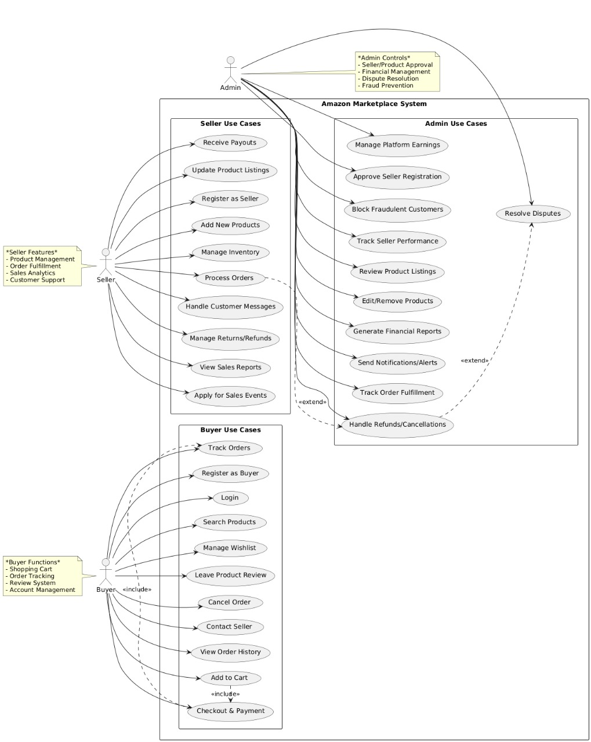

Activity Diagram

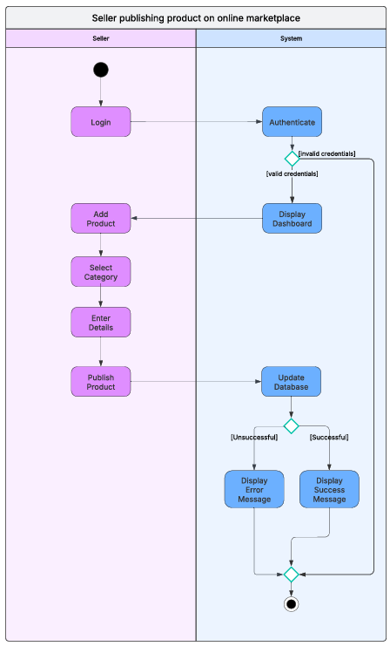

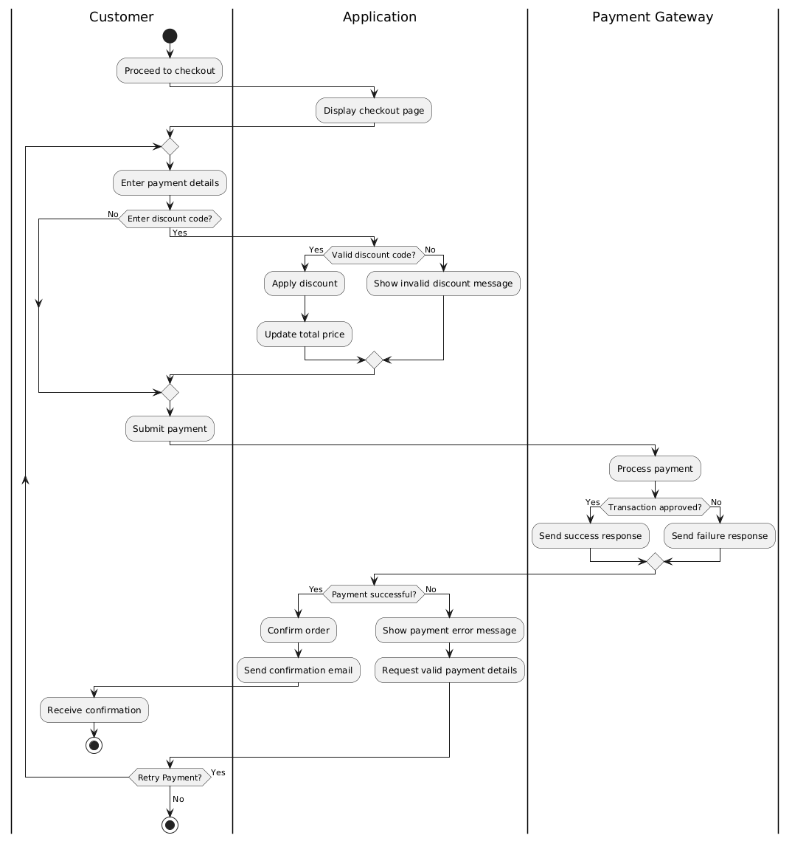

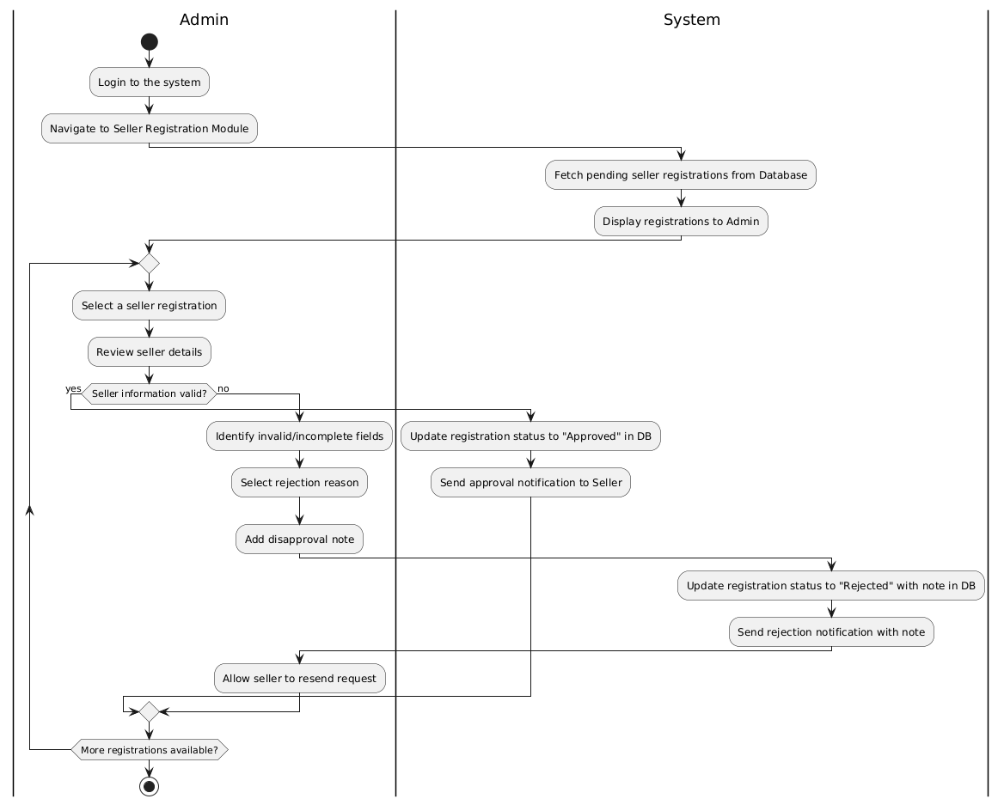

Sequence Diagram
Seller publishing product on online marketplace

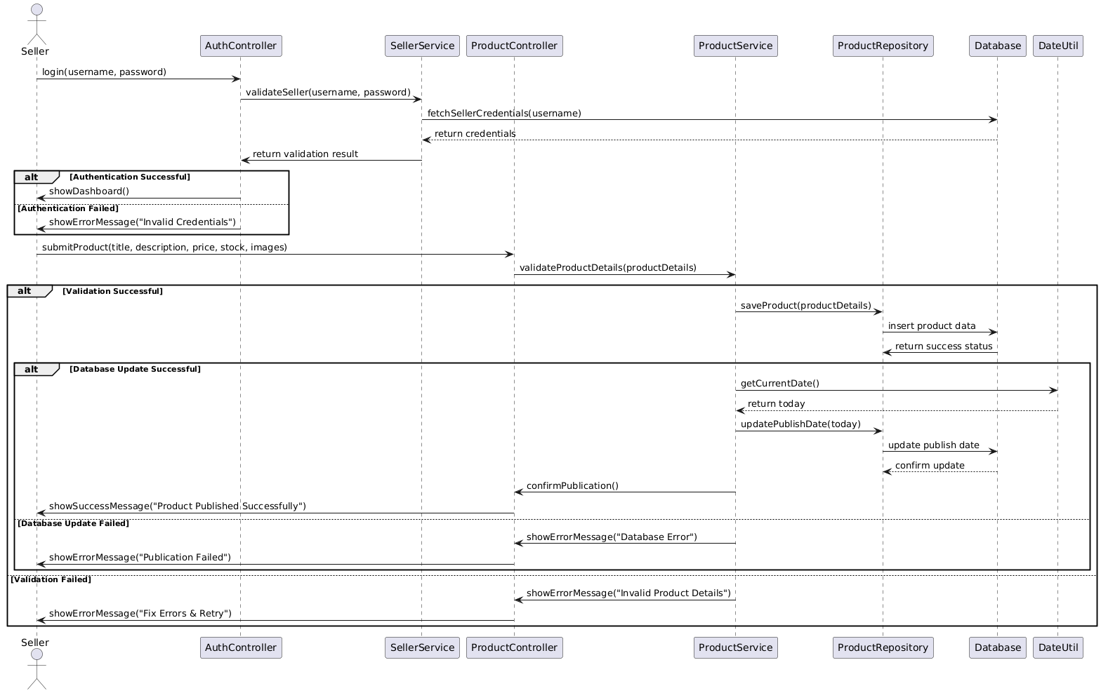
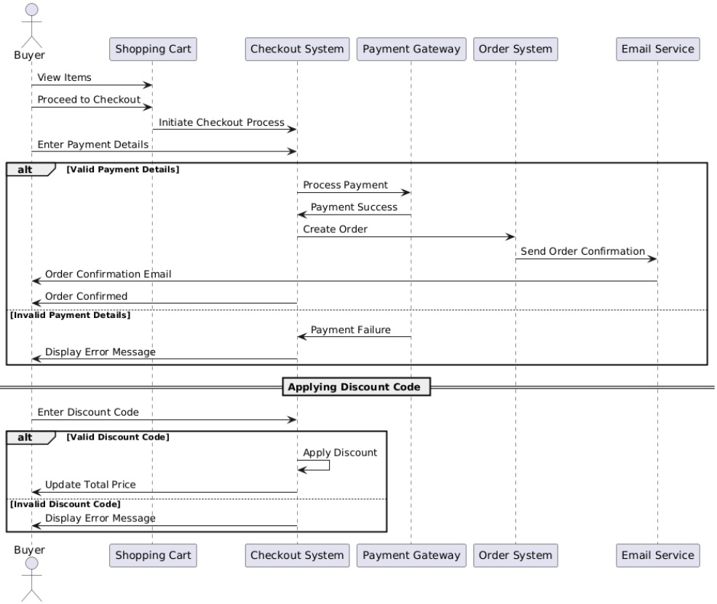

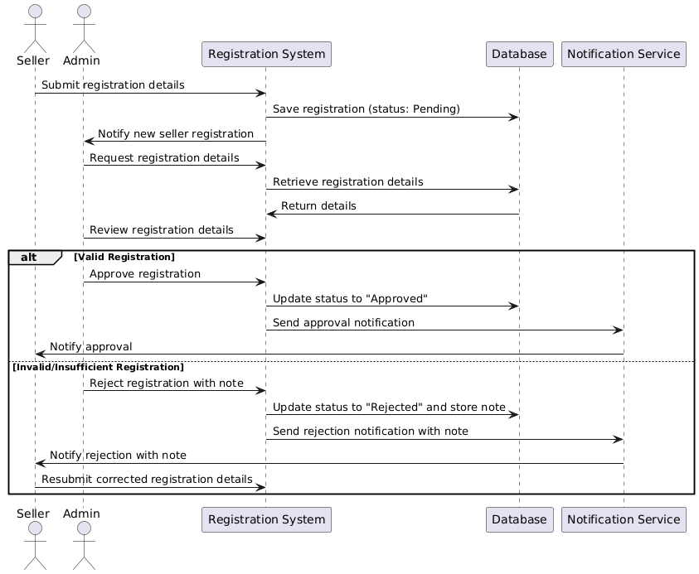

WBS Diagram
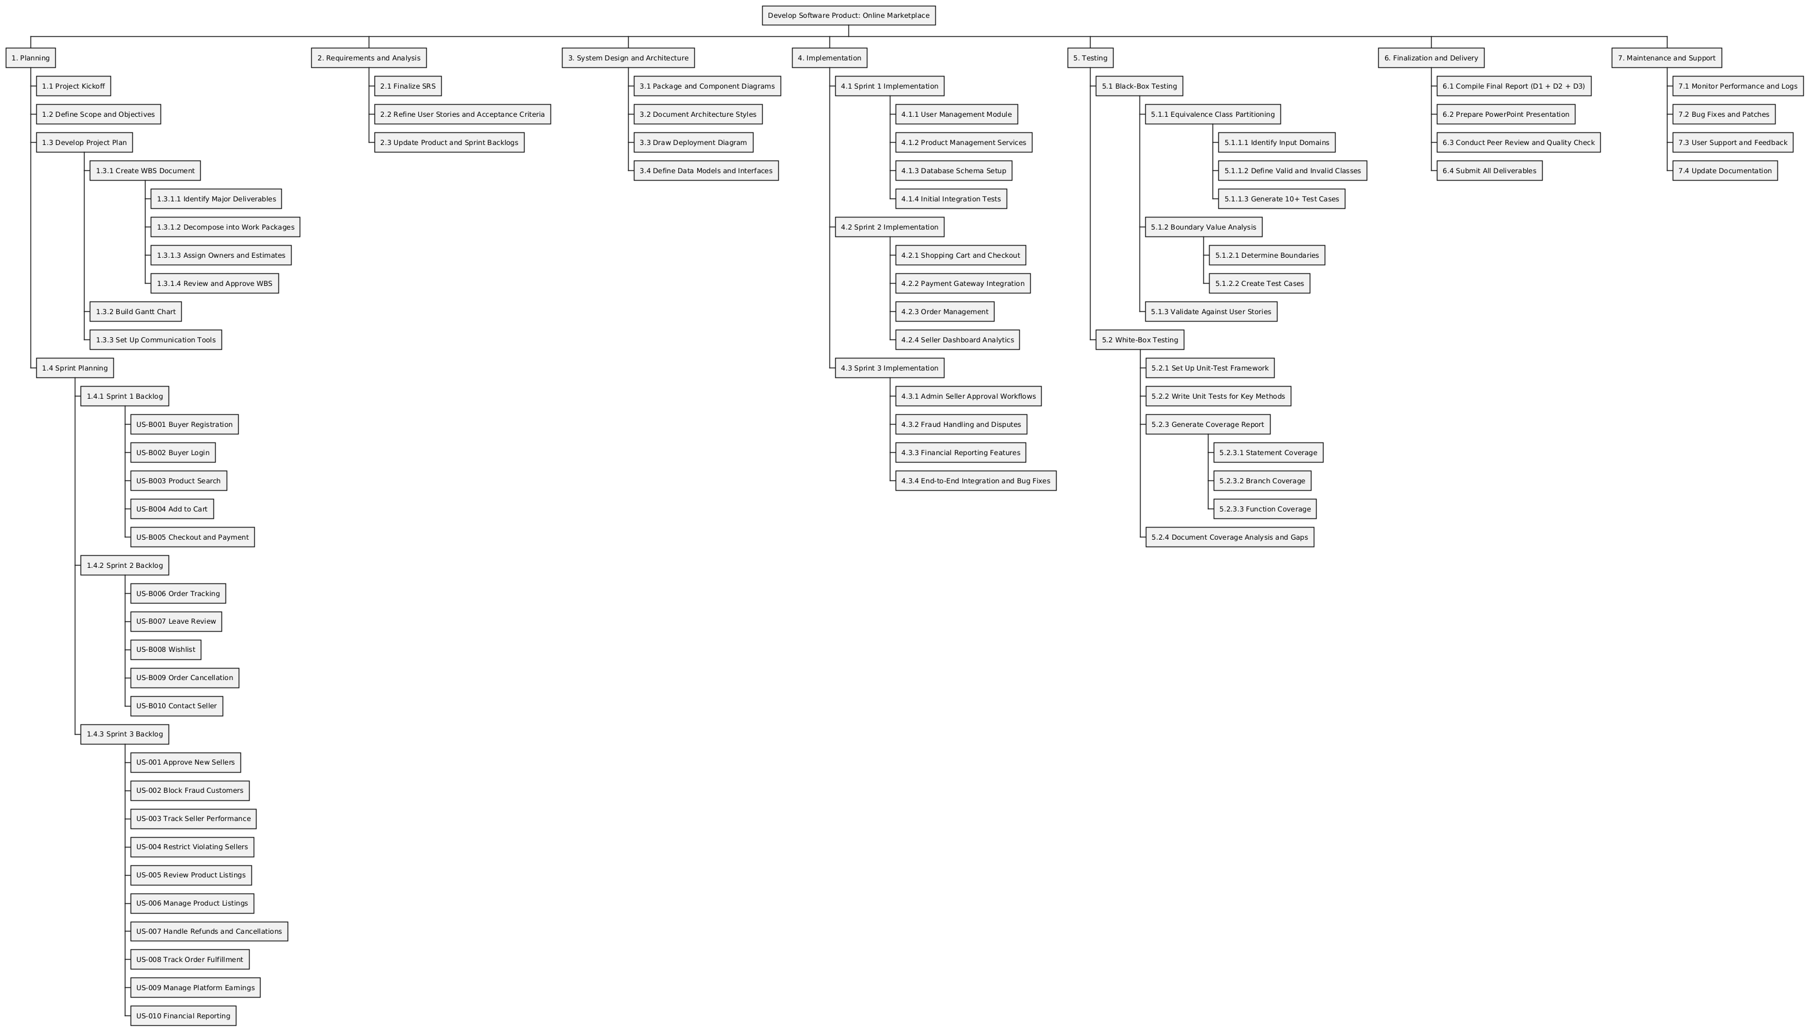

Gantt Chart Diagram
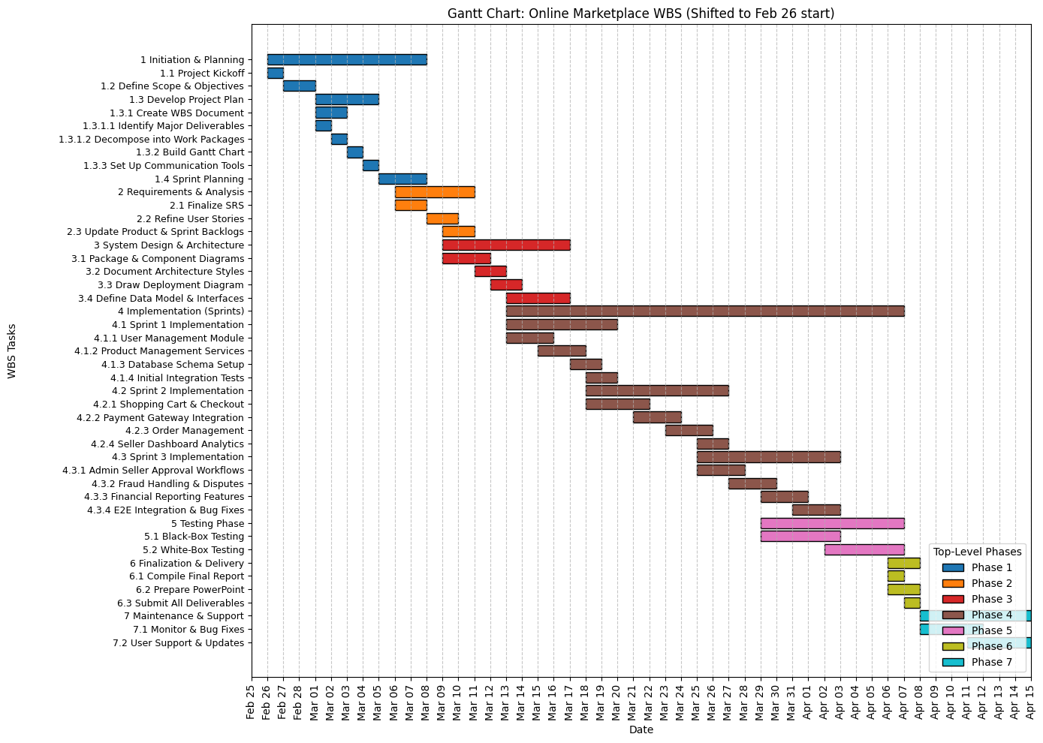

Trello Screenshot – (backlogs)
Product Backlog

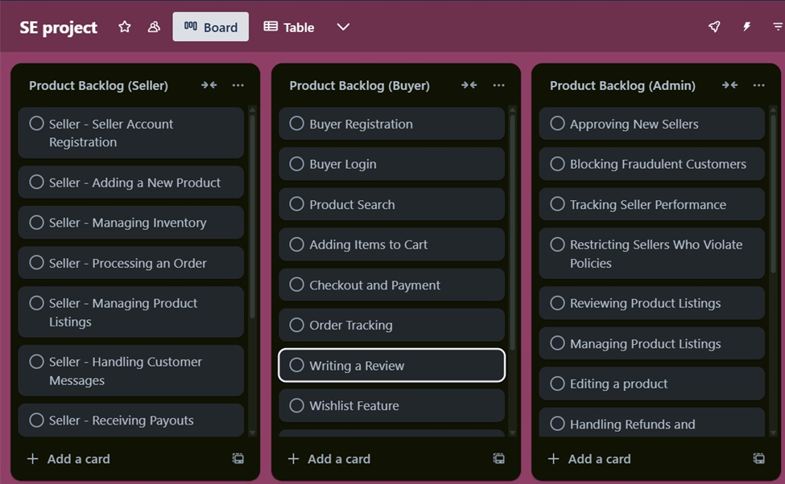

Sprint 1 backlog

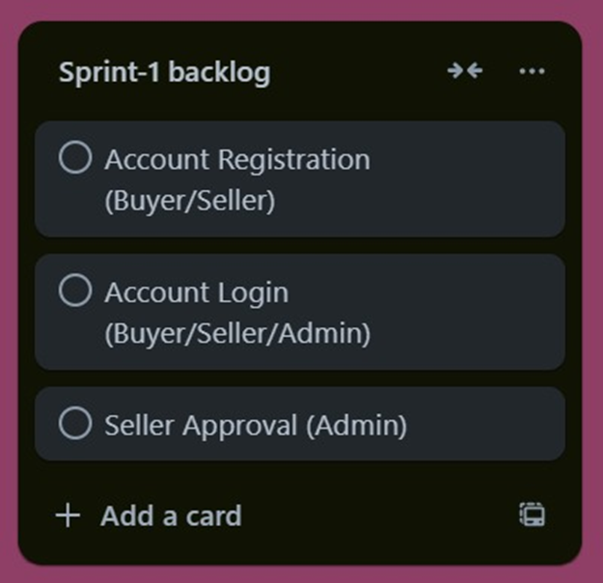

Spring 2 backlog

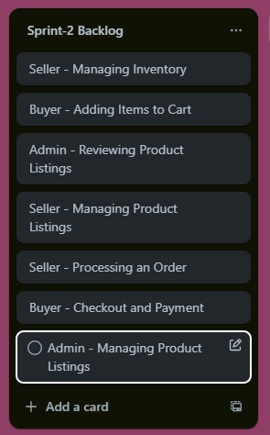

Sprint 3 backlog

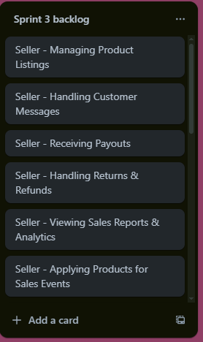

Product Burn down Chart
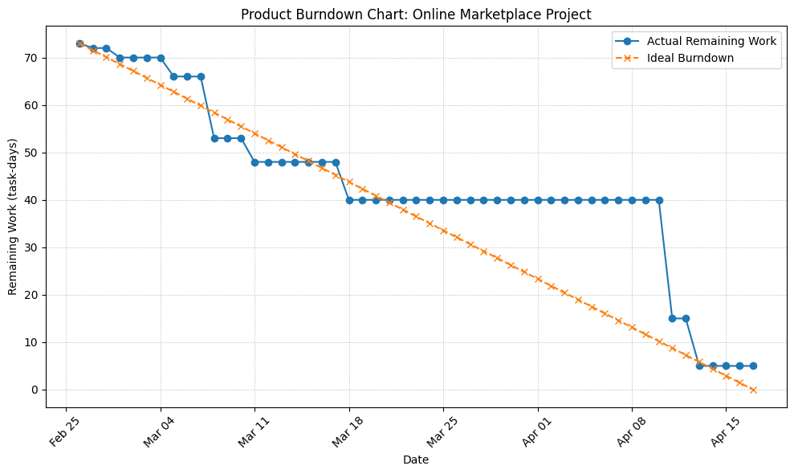

Architectural Style
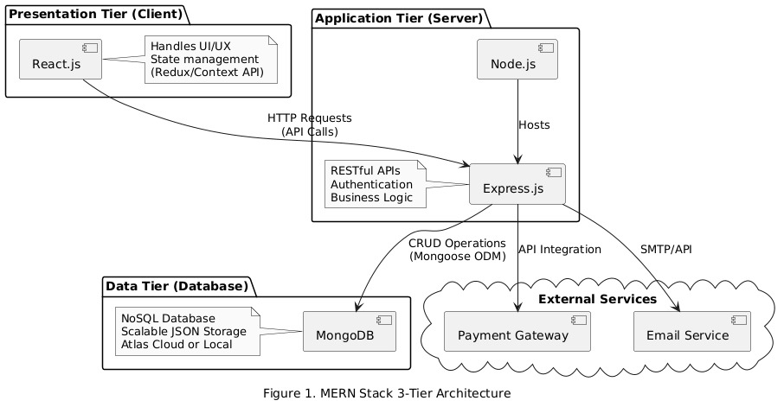

Deployment Diagram
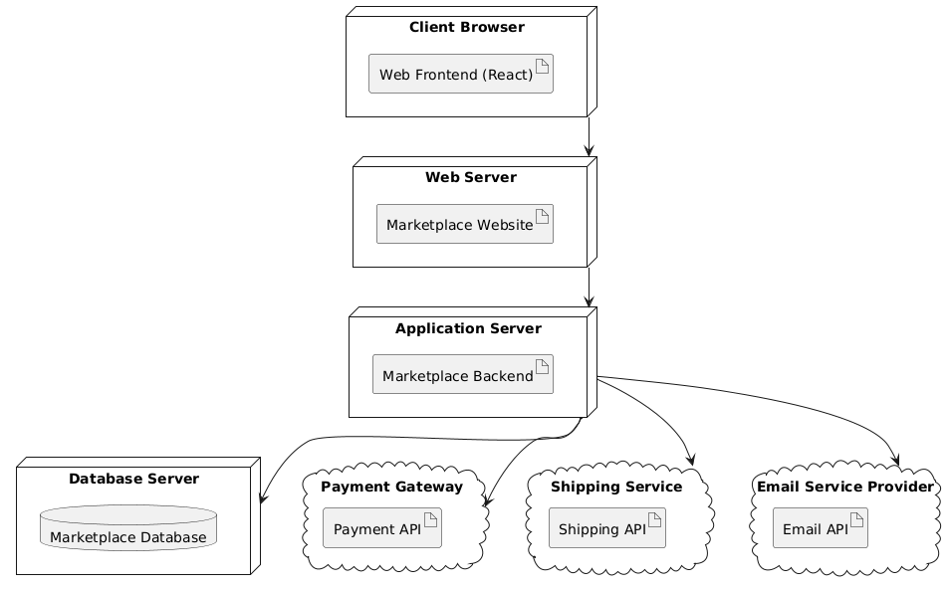

Package Diagram
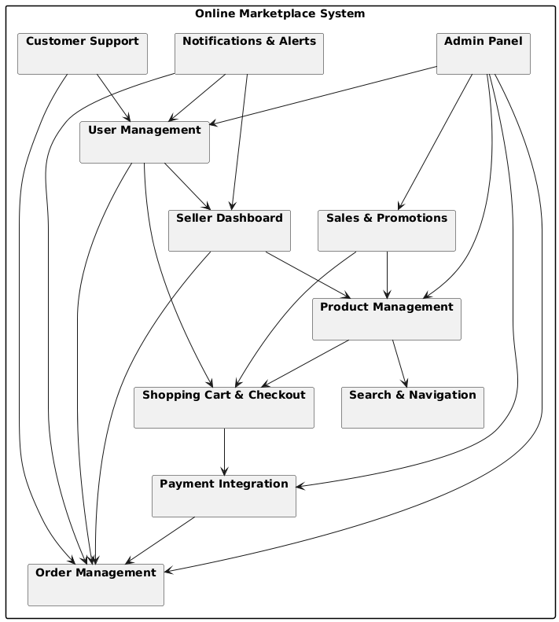

Component Diagram

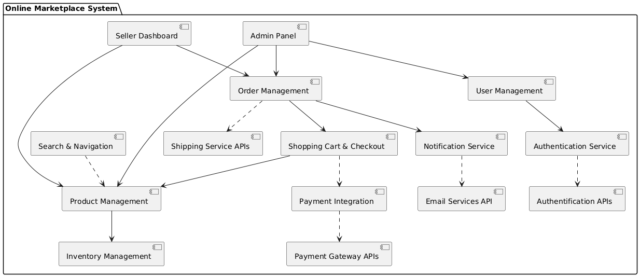

Lesson learnt, work division and team agreement

Lesson Learnt,
• Importance of Planning: Early project planning and requirement gathering are crucial to avoid rework and delays later.
• Effective Communication: Regular meetings and clear communication among team members helped in resolving issues faster and maintaining alignment.
• Version Control Discipline: Using tools like Git effectively prevented conflicts and ensured a smooth code integration process.
• Task Division Matters: Assigning tasks based on individual strengths led to better productivity and improved quality.
• Time Management: Balancing academic responsibilities with project deadlines taught us the value of setting realistic timelines and priorities.
• Testing is Critical: Proper black-box and white-box testing improved the reliability of the platform and helped catch issues early.
• User-Centric Thinking: Designing from the user’s perspective enhanced the usability and experience of our platform.
• Adaptability: Unexpected challenges (technical or coordination-related) required quick adaptation and problem-solving.
• Documentation Discipline: Maintaining consistent and updated documentation made reporting and final deliverables much easier.
• Agile Exposure: Practicing Agile sprints and backlogs gave us real-world experience in iterative software development.

Work division,
Work Division Between Group Members
- Khan
  - Led the System Design & Architecture phase
  - Created UML diagrams including class, component, and deployment diagrams
  - Managed database schema design and API structure
  - Contributed to Sprint 1 implementation (User Management Module)
- Ahmed
  - Focused on Frontend Development using modern UI frameworks
  - Handled user registration, product listings, and cart functionality
  - Wrote unit tests and contributed heavily to white-box testing coverage
  - Managed Gantt chart creation and WBS documentation
- Hussain
  - Managed Backend Development and server-side logic
  - Implemented payment gateway integration and order workflows
  - Took the lead on writing the final report and coordinating deliverables
  - Conducted black-box testing and compiled test case documentation

Team Agreement
Communication Channels:
- Primary Platform: Trello will be used for ongoing updates and day-to-day coordination.
- Secondary Channel: Email will serve for formal messages and sharing official documents.
- Urgent Contact: Phone or Discord will be used for time-sensitive issues requiring immediate attention.
Response Expectations:
- Trello: Team members are expected to reply within 2 hours during active working hours.
- Email: Responses should be provided within 24 hours.
- Phone/Discord: Used for urgent issues with immediate response expected.
Meeting Participation:
- Daily Standups: Required attendance; 15-minute sessions held on campus daily.
- Sprint Planning Meetings: Mandatory before the start of each sprint cycle.
- Sprint Reviews & Retrospectives: Compulsory at the end of every sprint.
Meeting Protocols:
- Meetings will be conducted virtually using Discord.
- The Scrum Master will lead and moderate all scheduled meetings.
- Meeting notes will be recorded by a different team member on rotation to track decisions and outcomes.
Pre-Meeting Preparation:
- All members should go through the meeting agenda ahead of time.
- Developers are responsible for updating the status of their tasks.
- The Product Owner must revise and present the current backlog state.
Version Control Guidelines:
- Repository Platform: GitHub will be used for codebase management.
- Branching Approach: Feature branches will be created and merged into the main branch post-review.
- Allowed Commits: Include source files, configuration, and documentation.
- Excluded Files: Sensitive data, personal materials, and large binaries must not be committed.
Task Assignment:
- Work will be distributed fairly, considering skillsets and individual workloads.
- Assignments will be coordinated collaboratively by the Scrum Master and team.
- Key stakeholders consist of the Product Owner, end users, and senior supervisors.
Assignment Submission Policy:
- All development and documentation must be finalized before sprint deadlines.
- Peer review is a prerequisite for every submission.
- The Scrum Master will conduct the final check before submitting deliverables.
Contingency Measures:
- In case of member dropout: Remaining responsibilities will be reassigned within the team.
- Consistent absenteeism: The Scrum Master will address the concern and escalate if unresolved.
- Academic misconduct: Any dishonest behavior will be reported and handled according to university regulations.

Black-box Testing
Equivalence class partiotioning

Feature | Parameter | Valid Classes | Invalid Classes
User Registration | Email format | user@domain.com, name.surname@co.uk | userdomain.com, @domain.com
 | Password length | 8–20 characters | < 8 characters, > 20 characters
Product Search | Query length | 1–100 characters | 0 characters, > 100 characters
Add to Cart | Quantity | 1–99 | 0, ≥ 100
Checkout | Payment method | CreditCard, DebitCard, Wallet, COD | Barter, Cheque
Discount Code | Code format | 5–10 alphanumeric characters | < 5 chars, > 10 chars, special chars
Order Cancellation | Time since order (hours) | ≤ 24 h | > 24 h
Product Rating | Score | 1, 2, 3, 4, 5 | 0, 6
Review Submission | Text length | 1–500 characters | 0 characters, > 500 characters
Wishlist Management | Items count | 1–100 | 0, ≥ 101
Contact Seller | Message length | 1–1000 characters | 0, > 1000 characters

Boundary – value Analysis

Feature | Parameter | Test Values
User Registration | Password length (chars) | 7, 8, 20, 21
 | Email local-part length (chars) | 0, 1, 64, 65
Product Search | Query length (chars) | 0, 1, 100, 101
Add to Cart | Quantity | 0, 1, 99, 100
Discount Code | Code length (chars) | 4, 5, 10, 11
Order Cancellation | Time since order (hours) | 23, 24, 25
Product Rating | Score | 0, 1, 5, 6
Review Submission | Text length (chars) | 0, 1, 500, 501
Wishlist Management | Items count | 0, 1, 100, 101
Checkout Amount | Total price (currency units) | 0, 1, 10 000, 10 001

White-box Testing
Field | Details
Tester: | Khan
Test Type: | Manual
Product: | Amana E-commerce Platform v1.0
Documented Date: | 29-Apr-2025
Suite: | TS-AM-01

T-001: Buyer Registration
- Test Item: Register New Buyer
- Description: Create a new buyer account using a valid email and password.
- Operation Procedure:
  - Navigate to “Sign Up” page
  - Enter name, user@example.com, password “Passw0rd!”
  - Click “Register”
- Pre-conditions: No existing session; registration page loads.
- Inputs: Email = user@example.com; Password = Passw0rd!
- Expected Output:
  - Confirmation message “Account created”
  - Redirect to login page
- Post-conditions: New buyer account exists in database.
- Cross References: R-BR-01, UC-BuyerRegistration

T-002: Buyer Login
- Test Item: Login Buyer
- Description: Authenticate with valid credentials.
- Operation Procedure:
  - Go to “Login”
  - Enter user@example.com / Passw0rd!
  - Click “Login”
- Pre-conditions: Buyer account exists; login page active.
- Inputs: Email = user@example.com; Password = Passw0rd!
- Expected Output:
  - User dashboard loads
  - Greeting “Welcome, [User]” displayed
- Post-conditions: Session cookie created; user logged in.
- Cross References: R-BL-01, UC-BuyerLogin

T-003: Product Search
- Test Item: Search Products
- Description: Search for “laptop” using the search bar.
- Operation Procedure:
  - Login → 2. Enter “laptop” in search field → 3. Click “Search”
- Pre-conditions: User logged in; products exist in inventory.
- Inputs: Query = “laptop”
- Expected Output:
  - List of matching products displayed within 3 seconds
  - Filters (price, brand) available on results page
- Post-conditions: Search results cached in session.
- Cross References: R-PS-01, UC-ProductSearch

T-004: Add to Cart
- Test Item: Add Item to Cart
- Description: Add 2 units of “Wireless Mouse” to cart.
- Operation Procedure:
  - On product page “Wireless Mouse” → 2. Quantity = 2 → 3. Click “Add to Cart”
- Pre-conditions: Product in stock ≥ 2; user logged in.
- Inputs: Product ID = 123; Quantity = 2
- Expected Output:
  - Cart count increments by 2
  - “Item added to cart” notification
- Post-conditions: Cart contains product ID 123, qty=2.
- Cross References: R-AC-01, UC-AddToCart

T-005: Checkout & Payment
- Test Item: Complete Purchase
- Description: Checkout cart with 1 item using credit card.
- Operation Procedure:
  - Go to Cart → 2. Click “Checkout” → 3. Enter card info → 4. Click “Pay”
- Pre-conditions: Cart not empty; user logged in.
- Inputs: Card number=4111 1111 1111 1111; Expiry=12/26; CVV=123
- Expected Output:
  - Payment success message
  - Order confirmation email sent
  - Order status = “Confirmed”
- Post-conditions: Order record created; payment logged.
- Cross References: R-CO-01, UC-Checkout

T-006: Apply Discount Code
- Test Item: Apply Promo Code
- Description: Apply code “SPRING10” for 10% off.
- Operation Procedure:
  - On Cart page → 2. Enter “SPRING10” → 3. Click “Apply”
- Pre-conditions: Cart subtotal ≥ minimum threshold; code valid.
- Inputs: Promo code=SPRING10
- Expected Output:
  - Subtotal reduced by 10%
  - “Promo applied” message
- Post-conditions: Discount reflected in final total.
- Cross References: R-DC-01, UC-ApplyDiscount

T-007: Order Tracking
- Test Item: Track Order Status
- Description: Check status of order #1001.
- Operation Procedure:
  - Go to “My Orders” → 2. Click order #1001 → 3. View tracking info
- Pre-conditions: Order #1001 exists; shipped.
- Inputs: Order ID=1001
- Expected Output:
  - Status timeline shows “Shipped → In Transit → Delivered”
  - Estimated delivery date displayed
- Post-conditions: Tracking updates cached.
- Cross References: R-OT-01, UC-OrderTracking

T-008: Add to Wishlist
- Test Item: Save Item for Later
- Description: Add “Bluetooth Speaker” to wishlist.
- Operation Procedure:
  - On product page → 2. Click “Add to Wishlist” icon
- Pre-conditions: User logged in; product exists.
- Inputs: Product ID=456
- Expected Output:
  - Wishlist count increments by 1
  - “Added to wishlist” toast
- Post-conditions: Wishlist contains product ID 456.
- Cross References: R-WL-01, UC-AddToWishlist

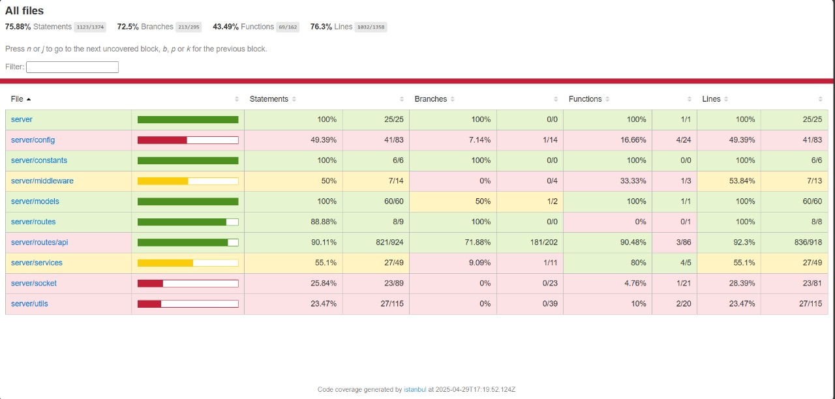

Appendix A: Glossary
- Marketplace: An online platform for buying and selling products.
- User: Any person interacting with the system (buyer, seller, administrator).
- Product Listing: The information and media provided by a seller to describe a product.
- Transaction: The process of purchasing a product, including payment and order confirmation.
- MFA (Multi-Factor Authentication): A security system that requires more than one method of authentication.
Appendix B: Analysis Models
Class Diagram:
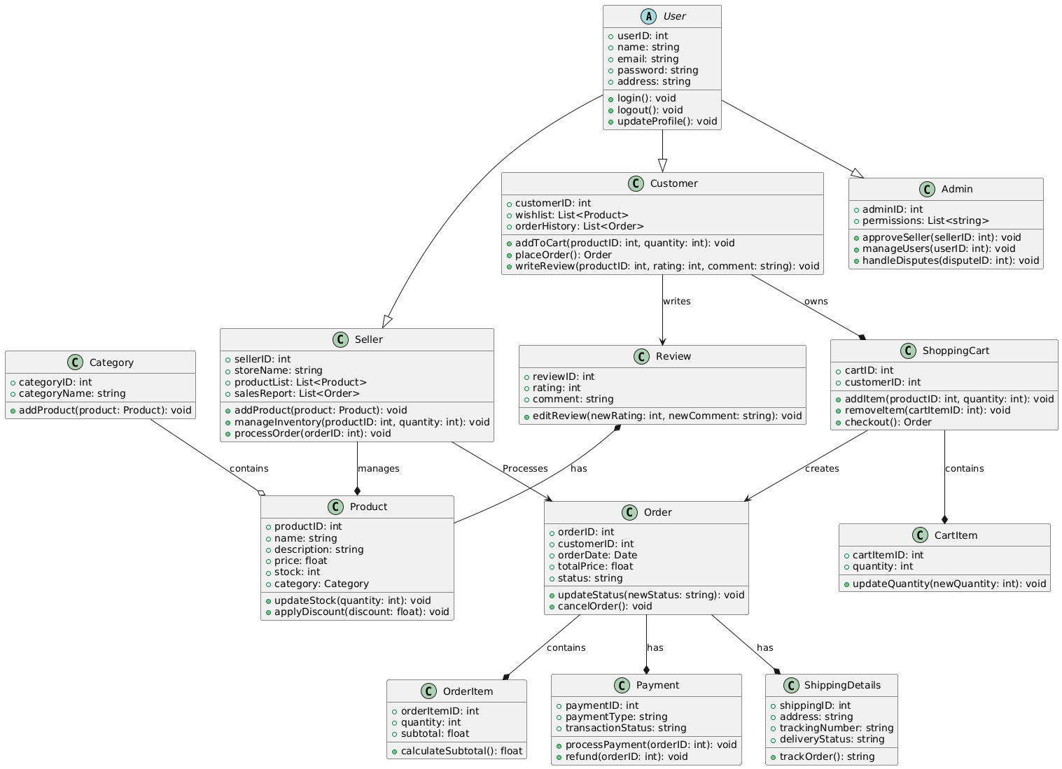

Appendix C: To Be Determined List
- Detailed API specifications for third-party integrations (payment, shipping, etc.) – TBD.
- Detailed wireframes for the user interface – TBD.
- Extended security protocols and audit schedule – TBD.
- Additional performance benchmarks and load testing scenarios – TBD.

